Parametric Genome Rearrangement
Mathieu Blanchette, Takashi Kunisawa, David Sankoff
Gene 172, GC 11-17, 1996.
Abstract
In this paper, we present a rapid algorithm that allows each operation to take on a range of weights, producing a relatively tight upper bound on the distance between single-chromosome genomes, by means of a greedy search with look-ahead. The efficiency of this algorithm allows us to test random genomes for each parameter setting, to detect gene order similarity.
- Formalization and Algorithm
- breakpoint:
Extend p to include element 0 (L) on the left and element n+1 (R) on the right , A breakpoint occurs between two adjacent elements that do not differ by 1

Example:

π= { 3 5 6 7 2 1 4 8 } has 5 breakpoints, (b(p) = 5).

L ● 3 ● 5 6 7 ● 2 1 ● 4 ● 8 R

- inversion、transposition
- Solves the problem recursively until all possible ways of arriving at the identity permutation in less than moves have been examined.
- approach :
- consider only moves that reduce the number of breakpoints.
- use a depth-first search with limited look-ahead and branch-and-bound .
2. Weights
- goal: to explore the effect of weighting each kind of move differently
- 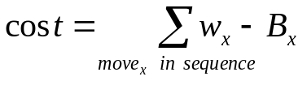
the weight of a move
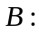 the number of breakpoint a move removes
- the inversion weight was fixed at 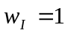, and we varied the transposition from somewhat less to somewhat more than 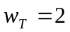
- for 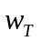< 2, transposition are favoured, while for >2, inversion are favored.
3. Example
- implementation: DERANGE II
- input :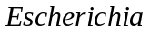 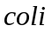 and 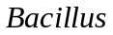 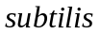
- result(inversion weight=1):
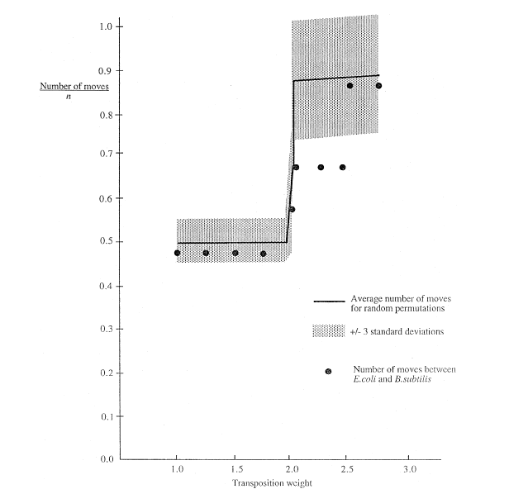
Created by : Hung-Wei Huang
Date : Mar. 14, 2003

